Press Information

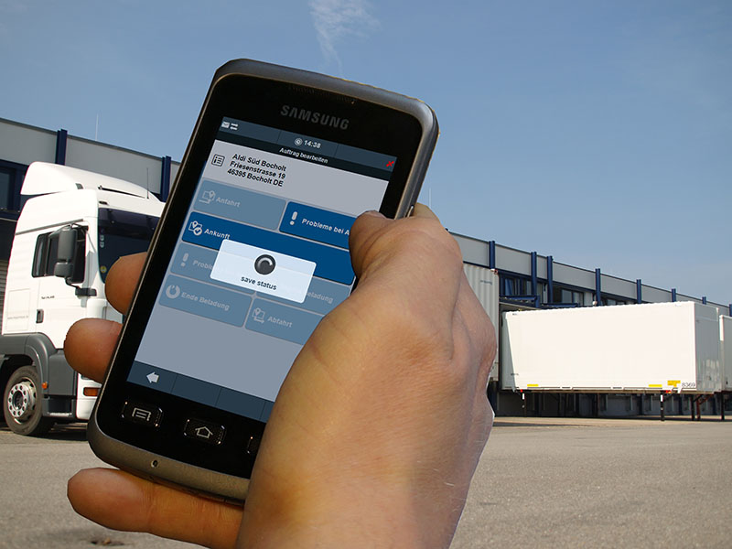

transport logistic / TIS

Smartphone telematics with data protection

The new telematics solution TISLOG Smart works on any web-enabled mobile phone without any risk for data protection. Source: KFDM / TIS

Bocholt, March 4, 2015 - At transport logistic (May 5 -8, 2015) under the name "TISLOG Smart" the TIS GmbH presents a new kind of mobile telematics solution for short-term use by subcontractors. The online solution works on any web-enabled mobile phone with a browser, while no time sensitive order and customer data is stored on the driver's cell phone at any time. In addition, TIS presents version 3.0 of the web portal Infodesk, which also allows to create and scheduled orders as of now. TIS will be exhibiting in Hall B2 at booth 317/518.

TISLOG Smart is a telematics solution for seamless order management with the use of subcontractors. The system does not require installation of other software or Apps and acquires the order data online over a website associated to a tour. At the beginning of the tour, the driver enters the specific website (URL) in the browser of his mobile phone and works on the jobs displayed there. After a delivery the new shipment status, photos or proofs of delivery are transferred to the secure server of TIS via data upload. With this constellation TISLOG Smart ensures at all times that sensitive order and customer data is protected and no data is stored on the driver's cell phone at any time.

Also featured at transport logistic will be web portal Infodesk in its new version 3.0. Infodesk is the online interface for the telematics data collected from mobile devices. In the portal, the data can be edited directly or automatically transferred from there to the customer's logistics software. Infodesks 3.0 now also allows to enter and schedule jobs. The function allows the assignment of part and full truck loads as well as groupage freight. By this the web portal takes over the functions of a transportation management system.

TIS is a rapidly expanding technology company with about 50 employees and a separate department for hardware development. The core product of the medium-sized company founded in 1985 is the telematics solution PSV3. It accelerates and optimizes the data exchange between the truck and head office. Among the special features of PSV3 range the easy installation of on-board computers, which are not permanently installed and are available on demand even as a vehicle-independent case solution. PSV3 is constantly being developed and adapted to the needs of customers in the logistics industry.

BACKGROUND The TIS GmbH

The TIS GmbH, based in Bocholt is a market leader for advanced telematics projects. TIS stands for “Technische Informationssysteme” (Technical Information Systems). For over 25 years now, the company develops intelligent products for mobile order management.
Based on industrial PDAs TIS has realized flexible telematics solutions for the logistics industry under the brand PSV3. Several technologies (GPRS/ EDGE, Wi-Fi, GPS, RFID, sensor technology) are merged into complete and customized systems. Key applications include groupage freight and full truckload services with integration of warehouse logistics. In special projects special versions for gas and liquid transport as well as for disposal and deposit logistics have emerged.

Company website: www.tis-gmbh.com

PRESS CONTACT
TIS Technische Informationssysteme GmbH | KfdM – Communication for mid-size businesses
Peter Giesekus  Müller-Armack-Straße 8  Technology Park Bocholt  D-46397 Bocholt  Phone: +49 28 71/27 22-0  E-Mail: marketing@tis-gmbh.de | Marcus Walter  Sudetenweg 12  D-85375 Neufahrn  Phone: +49 8165 / 999 38 43  Mobile: +49 170 / 77 36 70 5  E-Mail: walter@kfdm.eu

Status 03/2015

