Press Information

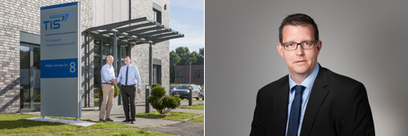

Josef Bielefeld (65) passes his part of management on to Markus Vinke (41).Source TIS GmbH.

Personnel / Telematics

New generation of TIS

Josef Bielefeld transfers his part of the management to Markus Vinke - Peter Giesekus continues to be managing director for sales and marketing.

Bocholt, September 8, 2016 - Josef Bielefeld (65), founder and owner of the mobile telematics solutions specialist TIS GmbH, passes on his part of ​​management to Markus Vinke (41) on October 1st. Thus, 30 years after its foundation, the medium-sized company performs its first alternation of generations. Markus Vinke will be responsible for all operational areas at TIS. Beside him Peter Giesekus keeps holding his position as the second managing director of marketing and sales, as he did in the past. Josef Bielefeld will continue to work for his company even after retiring from the company management, the ownership structure will remain unchanged. The shares of the GmbH are owned by the family Bielefeld.

Vinke is working for TIS since 2002 and first collected experience as a software developer and project manager here, before he took over the management of the software development department in 2012. The Diplom-Ingenieur für Elektrotechnik (graduate electrical engineer) played an essential role in the redevelopment of the modular telematics solution TISLOG based on new technologies such as web services, HTML5 and Java Script. At the orientation of TIS GmbH as a specialist for sophisticated and individual telematics solutions based on standard software, the native Borkener does not intend to change anything in the future: "The company should continue to grow solidly and with good judgement," promises Vinke.

Bielefeld had planned his personal succession two years ago and communicated it internally since 2015. "As a passionate engineer and proven leader with a keen sense of the economically feasible Markus Vinke was my preferred candidate for a long time," explains Bielefeld, who also has an engineering degree. With the new management, TIS is better equipped than ever for the future challenges in a rapidly changing technological environment.

BACKGROUND The TIS GmbH

The TIS GmbH, based in Bocholt is a market leader for advanced telematics projects. TIS stands for “Technische Informationssysteme” (Technical Information Systems). For over 25 years now, the company develops intelligent products for mobile order management.
Based on industrial PDAs TIS has realized flexible telematics solutions for the logistics industry under the brand PSV3. Several technologies (GPRS/ EDGE, Wi-Fi, GPS, RFID, sensor technology) are merged into complete and customized systems. Key applications include groupage freight and full truckload services with integration of warehouse logistics. In special projects special versions for gas and liquid transport as well as for disposal and deposit logistics have emerged.

Company website: www.tis-gmbh.com

PRESS CONTACT
TIS Technische Informationssysteme GmbH | KfdM – Communication for mid-size businesses
Peter Giesekus  Müller-Armack-Straße 8  Technology Park Bocholt  D-46397 Bocholt  Phone: +49 28 71/27 22-0  E-Mail: marketing@tis-gmbh.de | Marcus Walter  Sudetenweg 12  D-85375 Neufahrn  Phone: +49 8165 / 999 38 43  Mobile: +49 170 / 77 36 70 5  E-Mail: walter@kfdm.eu

Status 09/2016

