Press Information

LogiMAT / Warehouse turnover
TIS develops optical search aid together with DIVIS
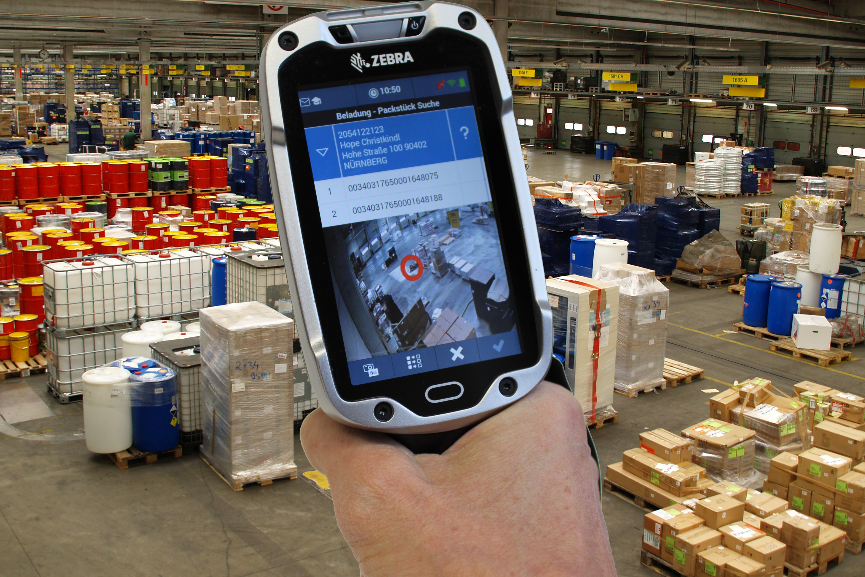
On the LogiMAT, TIS will be showing an optical search aid for the warehouse under the name "TISLOG intra Vis".
Source TIS GmbH.
TISLOG intra Vis shows warehouse employees the current position of shipments - Integration of video system solution CargoVIS from DIVIS in TISLOG - New scan handles from our own production
TIS GmbH, which is specialized in mobile telematics solutions for warehousing and transport, is presenting an optical search aid for warehouses at the LogiMAT logistics fair (March 14 - 16) under the name "TISLOG intra Vis". The solution, developed in cooperation with DIVIS (Deutsche Industrievideosystem GmbH), helps the storage staff find a piece of goods by means of a fast-retrievable photo showing the Colli(s) at their current storage position. Behind this is the video system solution CargoVIS from DIVIS, which activates an assigned camera at each scan event, links the photo with storage position and barcode and archives it. TISLOG intra Vis can be activated directly via the warehouse scanner in use, which is also used to process the electronic cargo list. As a further novelty, TIS will be showcasing professional fixtures and handles from its own production for the latest generation of terminals. TIS and DIVIS will be exhibiting together in Hall 7 at booth A05 / A07.
"With TISLOG intra Vis, we integrated the video system solution CargoVIS from DIVIS into our logistics software TISLOG," notes TIS CEO Markus Vinke. The networking of upstream and downstream systems and platforms is one of the “core competences of TIS, which will be further expanded in the future”, Vinke added. The goal is the complete digitalization of all processes as a concrete implementation of Logistics 4.0.
Also on the LogiMAT TIS shows all other available modules of TISLOG mobile. Especially for intralogistics, modules have been developed for the efficient detection of blockages or the documentation of damages and loading areas. All functions can be activated directly via the mobile device.
With regard to hardware, customers can choose among the available mobile devices with Android operating systems - in addition to commercially available smartphones, industrial touch-based computers such as the TC8000 or TC75 from Zebra and the ScanPal EDA50 from Honeywell can also be used. All three units are part of the tested TISWARE product portfolio and can be inspected at the booth.
In May 2015, TIS had completely restructured its product range. Under the name of TISLOG Logistics & Mobility, the medium-sized family-owned company offers modular solutions for small, medium and large companies, which are constantly being further developed.

BACKGROUND The TIS GmbH

The TIS GmbH, based in Bocholt is a market leader for advanced telematics projects. TIS stands for “Technische Informationssysteme” (Technical Information Systems). For over 25 years now, the company develops intelligent products for mobile order management.
Based on industrial PDAs TIS has realized flexible telematics solutions for the logistics industry under the brand PSV3. Several technologies (GPRS/ EDGE, Wi-Fi, GPS, RFID, sensor technology) are merged into complete and customized systems. Key applications include groupage freight and full truckload services with integration of warehouse logistics. In special projects special versions for gas and liquid transport as well as for disposal and deposit logistics have emerged.

Company website: www.tis-gmbh.com

PRESS CONTACT
TIS Technische Informationssysteme GmbH | KfdM – Communication for mid-size businesses
Peter Giesekus  Müller-Armack-Straße 8  Technology Park Bocholt  D-46397 Bocholt  Phone: +49 28 71/27 22-0  E-Mail: marketing@tis-gmbh.de | Marcus Walter  Sudetenweg 12  D-85375 Neufahrn  Phone: +49 8165 / 999 38 43  Mobile: +49 170 / 77 36 70 5  E-Mail: walter@kfdm.eu

Status 01/2017

