Press Information

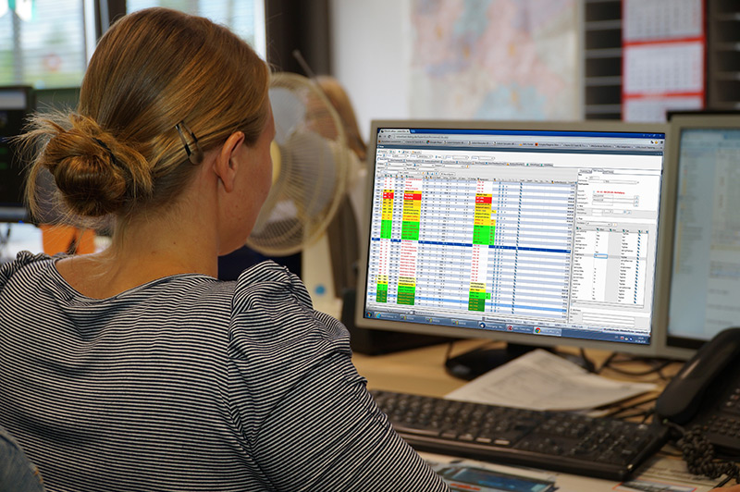

Caption: At the LogiMAT, TIS will be showing, among other things, the newly developed TISLOG MDM solution for the management of mobile devices. Source: TIS.

Trade show LogiMAT / Telematics
TIS: New hardware and software

Self-developed solution for management of mobile devices - New custom-designed scan handles and charging stations - New hardware from Honeywell and Zebra

Bocholt, November21, 2017 - TIS GmbH, specializing in mobile telematics solutions for warehousing and transport, will be presenting a self-developed solution for the management of mobile devices under the name TISLOG MDM at the LogiMAT trade fair (13 to 15 March 2018) as well as new Scan handles and charging stations from the in-house development. In addition, TIS will be showing the latest hardware developments from Honeywell and Zebra. TIS is exhibiting in hall 8 at booth A05.
TISLOG MDM is a new software for "Mobile Device Management" (MDM), which has been optimized for the requirements of the logistics industry. With TISLOG MDM TIS offers a self-developed alternative to third-party solutions. The tool enables the efficient and centralized management of all mobile telematics devices used and is an integral part of the TISLOG software family. The trade fair novelty, for example, enables fast and wireless transmission of software updates to data terminals, scanners, tablets or smartphones as well as the backup and inventory of all mobile devices. Intuitive user guidance makes it easy to log in and set up new devices. The same applies to the removal of devices and the associated deletion of company data.

One option is the simple and secure management of master data as well as the remote cleaning of stolen or lost devices. In addition, TISLOG MDM allows data traffic to be controlled by its own application firewall on mobile devices. TISLOG MDM is suitable for organizations with their own and other fleets. Only devices with Android are supported.

Other highlights at the TIS stand include the new products from the TISPLUS range of accessories. Here the telematics specialists from Bocholt show special scan handles for the Honeywell mobile computers of types EDA50 and CT50.
The self-developed and produced attachable handles improve the ergonomic handling and thus significantly enhance scanning performance. The mounted scan handle harmonizes with the standard charging station and does not restrict the operation of the built-in camera.

The likewise new TISPLUS vehicle charging station for the Zebra TC51/ 56 impresses with its compact and robust design. Screw holes in the front also ensure uncomplicated mounting on the dashboard or on a RAM mount. The cradle has a wide input voltage range of 9 to 30 volts.

In the TISWARE range, TIS presents the latest devices from its long-standing hardware partners. The models Dolphin CT60 and EDA70 from Honeywell as well as the TC25 from Zebra can be examined live. The Dolphin CT60 Touch Mobile Computer builds on the benefits of its predecessor, the CT50, and is compatible with its software and accessory portfolio. Equipped with the Android operating system, the mobile terminal in smartphone-look is designed to assist employees throughout their working day as a digital assistant.

The industrial-grade Honeywell Tablet EDA70 is suitable for work areas with high scan volume due to its slim, lightweight and yet very robust design. The EDA70 is equipped with a fast processor, a scanner for 1D and 2D barcodes and an integrated camera. The powerful battery is designed to last a working shift.

Zebra's TC25 mobile computer is brand new and available in either a touch-screen version or with a keyboard. The low-cost device has a barcode scanner and an 8 MP autofocus color camera, which is, for example, suitable for damage documentation. An attachable PowerPack extends the battery life if necessary and ensures uninterrupted operation.

BACKGROUND The TIS GmbH

TIS GmbH, headquartered in Bocholt, is one of the market leaders for sophisticated telematics projects. TIS stands for „Technische Informationssysteme“ (Technical Information Systems) and is a rapidly expanding technology company with around 50 employees and its own hardware development department. The company has been developing intelligent products for mobile order management since 1985. Based on industrial PDAs and smartphones, TIS has implemented flexible telematics solutions for the logistics industry. Several technologies (GPRS/ EDGE, Wi-Fi, GPS, RFID, sensor technology) are merged into complete and customized systems. Key applications include groupage freight and full truckload services with integration of warehouse logistics. In special projects special versions for gas and liquid transport as well as for disposal and deposit logistics have emerged.
Company website: www.tis-gmbh.com

PRESS CONTACT
TIS Technische Informationssysteme GmbH | KfdM – Communication for mid-size businesses
Peter Giesekus  Müller-Armack-Straße 8  Technology Park Bocholt  D-46397 Bocholt  Phone: +49 28 71/27 22-0  E-Mail: marketing@tis-gmbh.de | Marcus Walter  Sudetenweg 12  D-85375 Neufahrn  Phone: +49 8165 / 999 38 43  Mobile: +49 170 / 77 36 70 5  E-Mail: walter@kfdm.eu

Status 11/2017

